Easy Trust Claim
- Claim: Patient and Doctor can successfully sign up and log in to the system
- Evidence: Unit and Manual tests passed
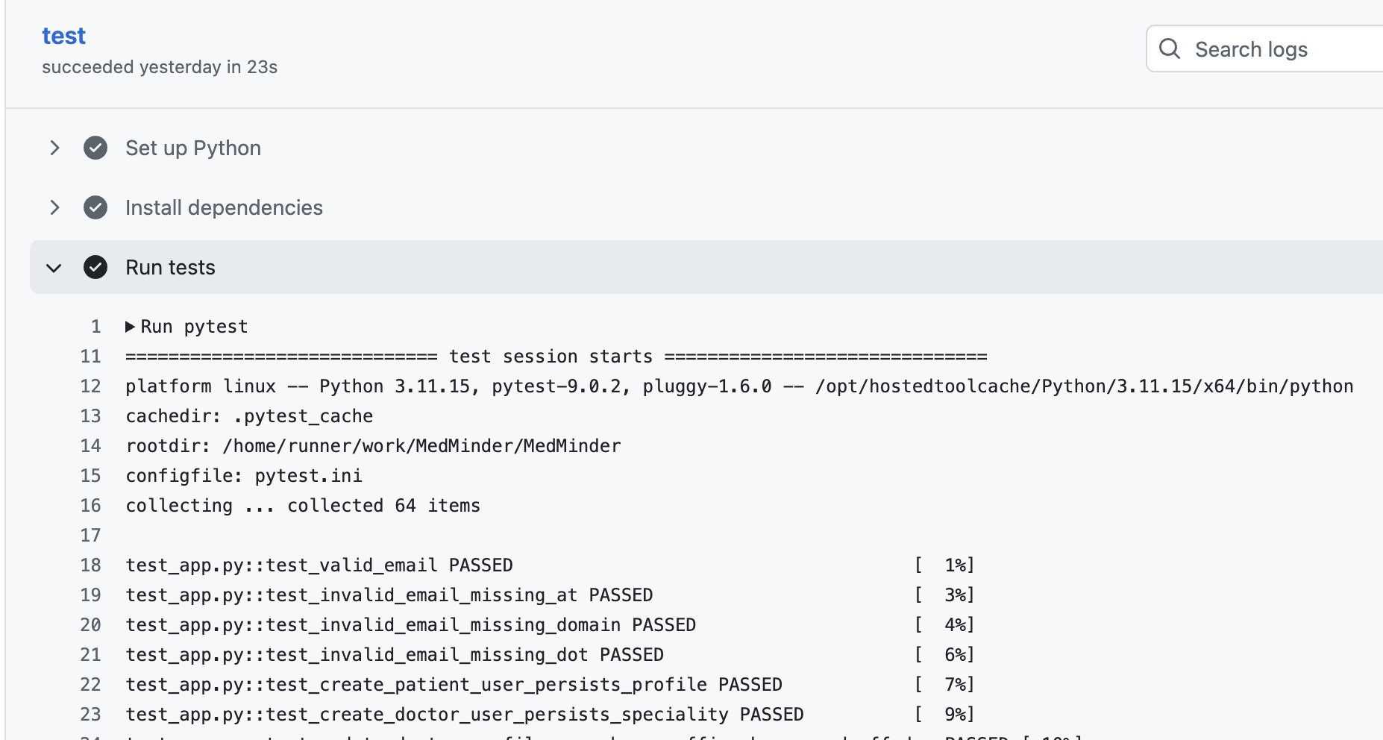
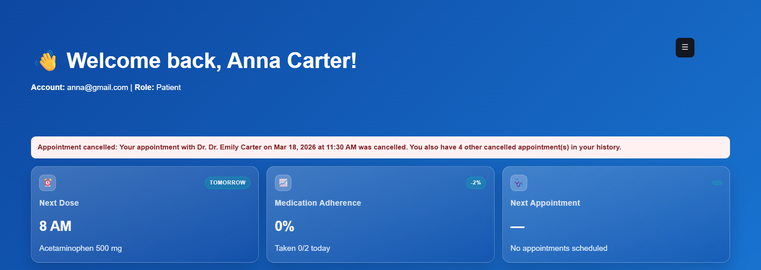
- Limitation:
  - Doctors cannot add their custom speciality except for the ones mentioned in the dropdown
  - The system does not have a forget password functionality
  - There’s no email verification
  - Currently does not support Field validation

Medium Trust Claim
- Claim: Patients can successfully book and cancel an appointment and the doctor can also cancel an appointment
- Evidence: Unit and Manual test passed
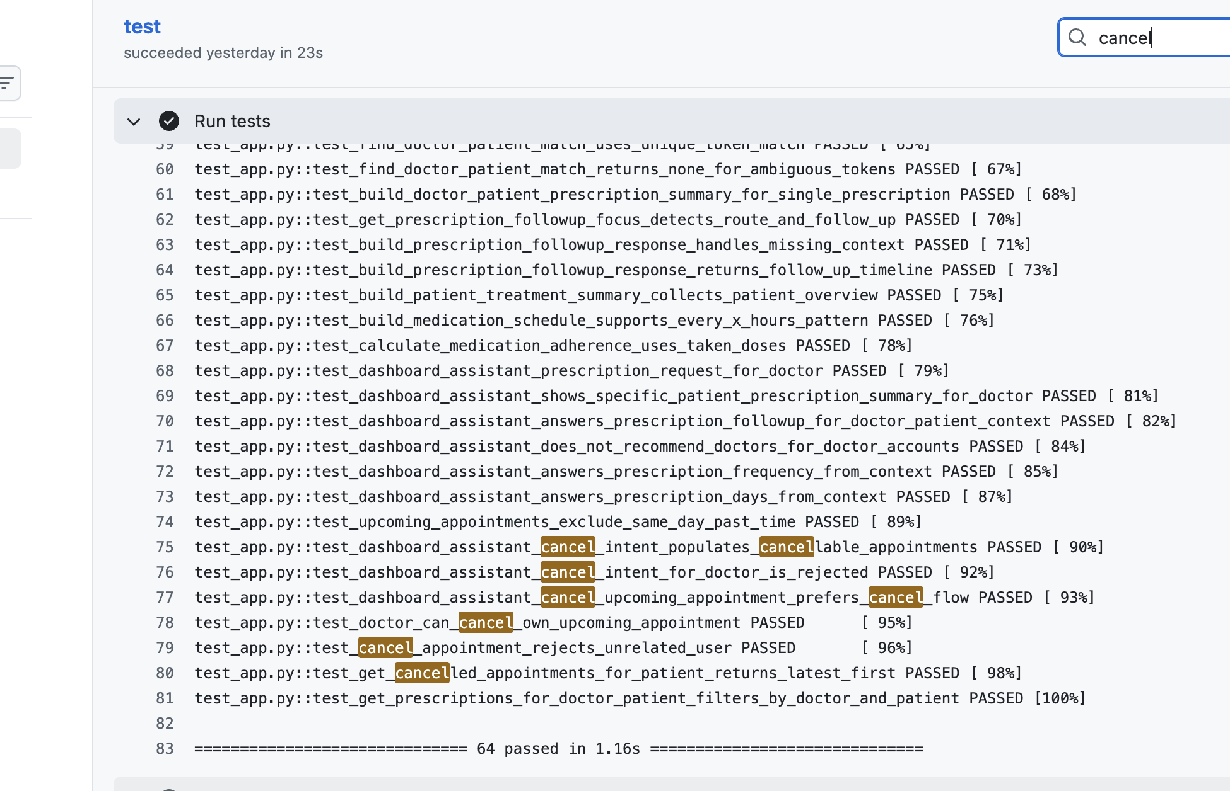
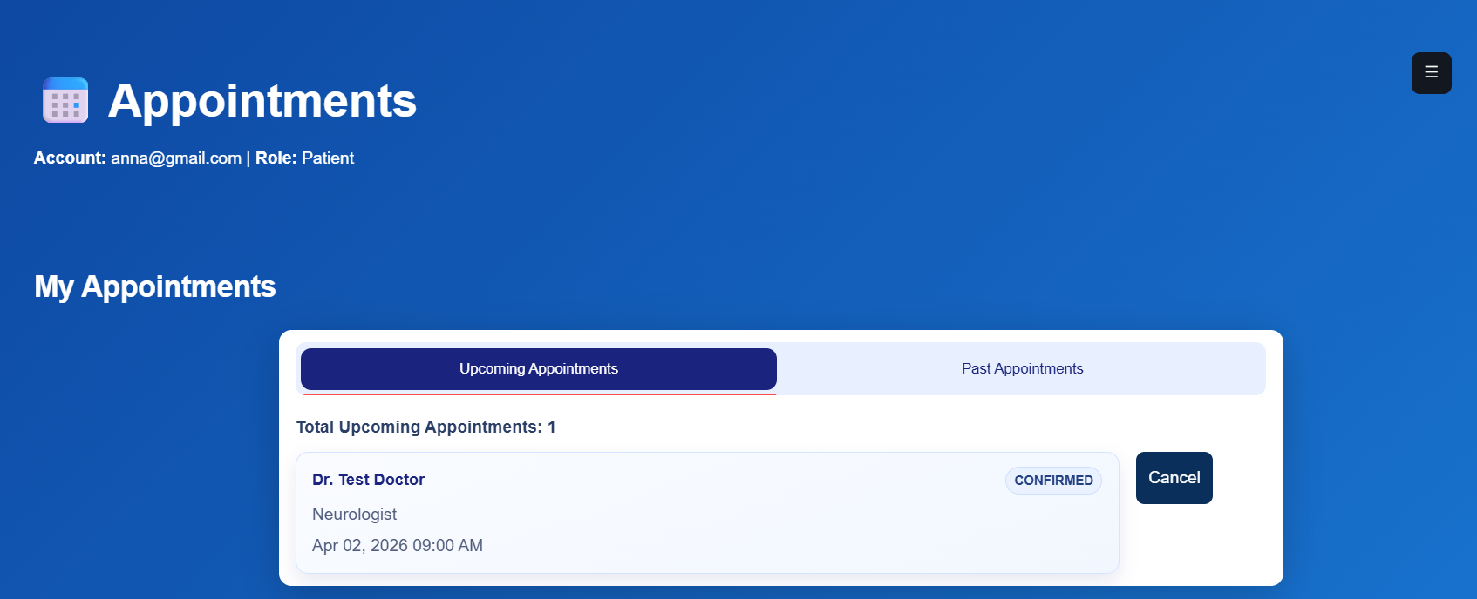
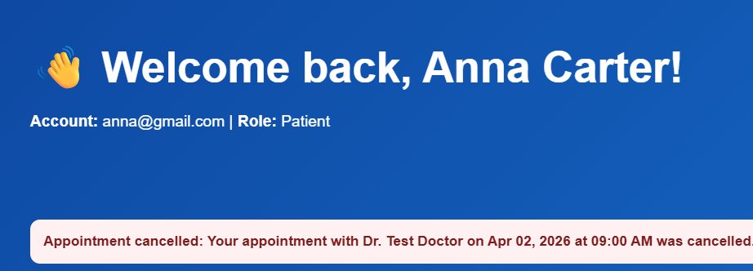
- Limitation:
  - Cannot directly book an appointment with AI chatbot
  - No confirmation check when booking an appointment
  - Doctor cannot cancel an appointment from the chatbot
  - Patient can book an appointment at the same date/time with different doctors

Hard Trust Claim
- Claim: Patients can view their treatment summaries from multiple providers in one view
- Evidence: Unit and Manual tests passed
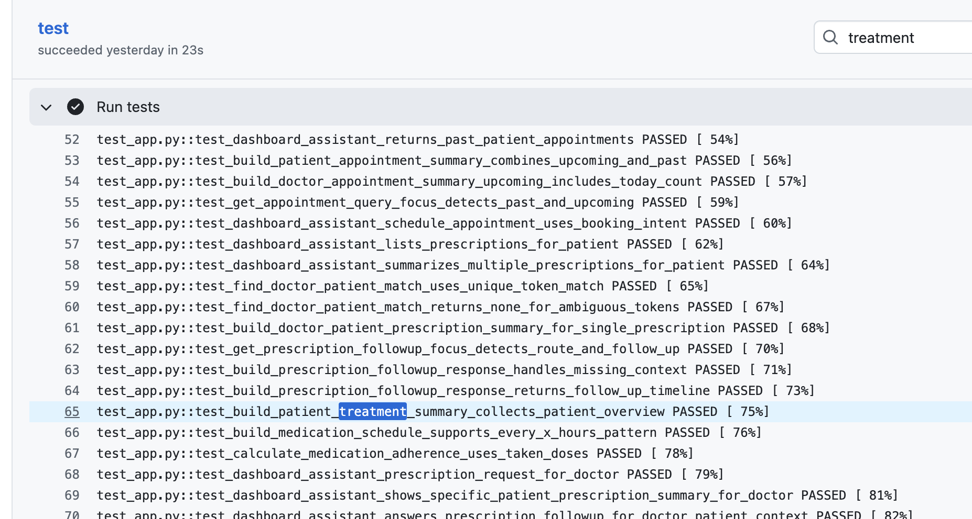
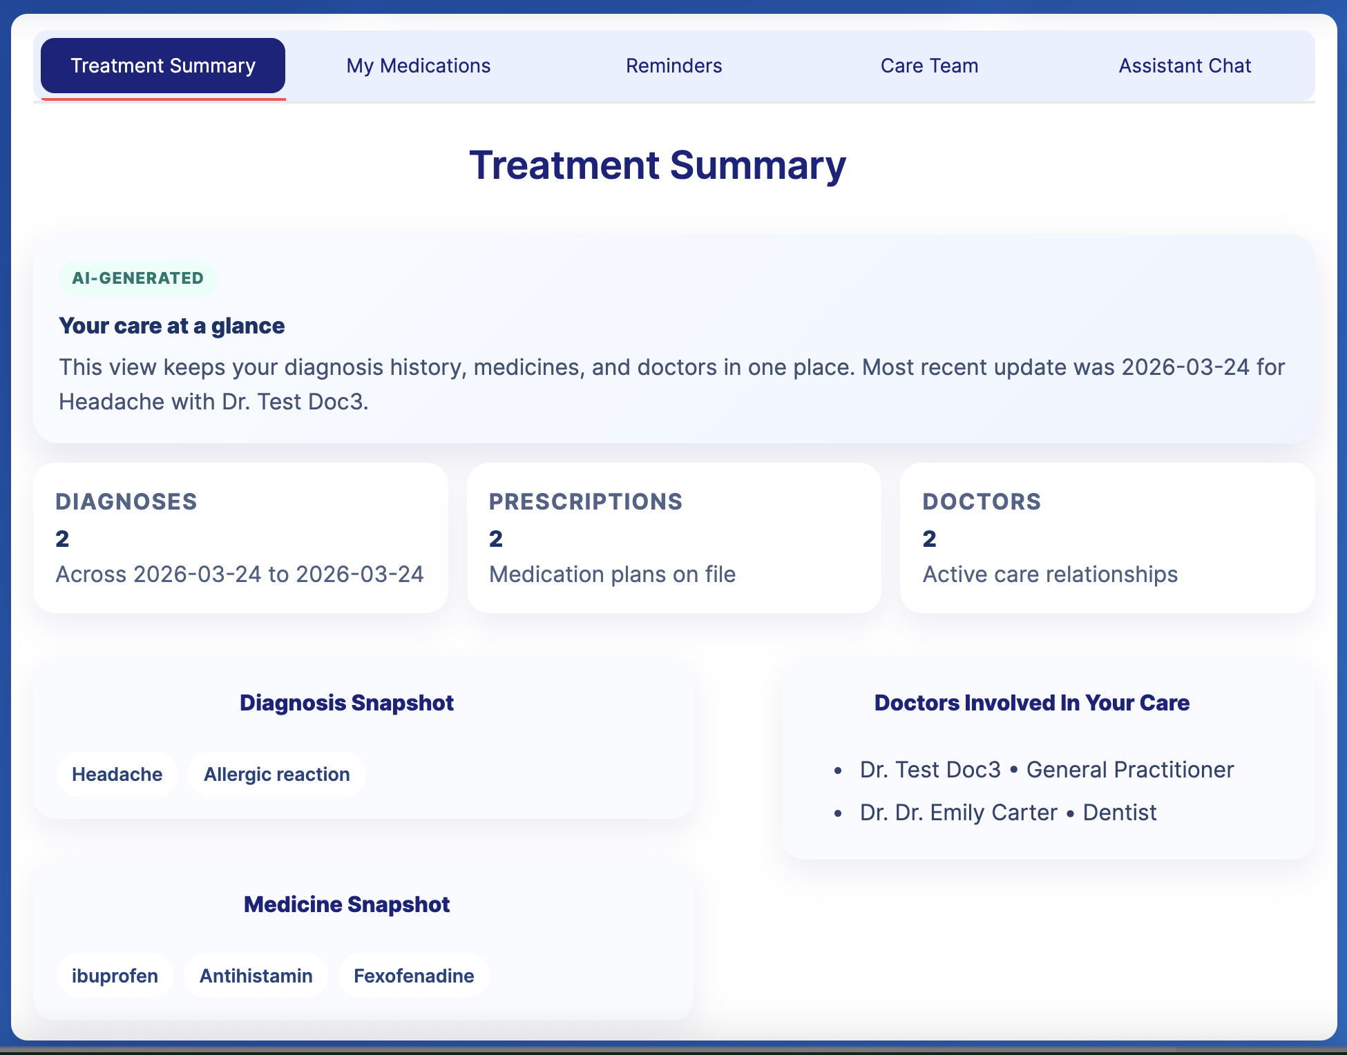
- Limitation:
  - Summarised only if there are multiple appointments
  - Can show multiple medicines or diagnoses with the same name in snapshots
  - Does not show upcoming appointments

